**Voice Based Email for the Visually Impaired**

**Rahul Ahire1, Poonam Bankar1, Aniket Bhosale1, Deepak Khette1, Prof. Ajita Mahapadi2**

1Department of Computer Engineering, D Y Patil School of Engineering, Lohegaon, Maharashtra India

2Professor, Department of Computer Engineering, D Y Patil School of Engineering, Lohegaon, Maharashtra India

**ABSTRACT**

E-mails are the most reliable way of communication over Internet, for sending or receiving some important

information. But there is a special criterion for humans to access the Internet and the criteria is you must be able

to see. A survey shows that there are more than 285 million visually challenged people around the globe. That is,

around 285 million people are unaware of how to use Internet or E-mail. So, forgiving an equal status to visually

challenged people we have come up with this project idea which provides the client(user) with ability to send

mails using voice commands without the need of keyboard or any other visual things. This system can be used

effectively by handicapped and illiterate people as it is based on TTS, STT CONVERSIONS and IVR

technologies.

**Keywords:** TTS, STT CONVERSIONS and IVR

1. **INTRODUCTION**

The Internet is a vast network which connects millions across the globe in various ways. So, talking about communication over the internet the first thing that comes to thought, is, E-mails. E-mails are extensively used form of online communication, both formally and informally as well. Despite social media, E-mails being the very traditional form of communication have still been the best to date. But the purpose of any service is to serve all mankind, and hence, E-mails should also be such that, they can be easily used by people from all races of life. But Traditional E-mail Systems are accessible to several but the visually impaired class on the globe, and also various other handicapped people. So, in order to remove this drawback, An E-mail System for the visually impaired individuals would be an incredible breakthrough. Hence, this application has been thought of. Talking of the application, the application will be a web-based E-mail System for visually impaired people. Using Interactive voice response (IVR), which would enable everyone to control their own mail accounts using their voice only and also, they would be able to read, send, and perform all the other user tasks which are offered by the traditional E-mail Systems. The system will prompt the user with voice commands to perform certain actions and the user will respond to the same with voice input. The main advantage of this system is the use of (text) keyboard is completely eliminated, which means, the user will have to respond through their own voice and mouse events only. Now you must be thinking that how will a impaired person will see the right position on the screen for doing mouse clicks event. But this system will perform actions based on the clicks only that is left or right click, it does not depend on the area(portion) of the screen where the cursor is placed before the click giving user the freedom to click anywhere on the screen.

1. **METHODS AND MATERIAL**

**SPEECH TO TEXT:**

Speech to Text conversion is the process of converting

Spoken words into texts. This process is also called Speech recognition.

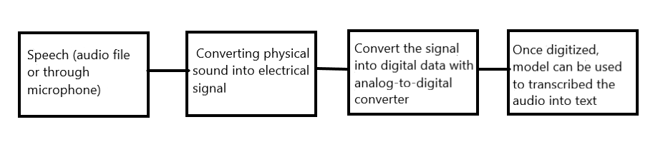

Fig 1.1: Speech to Text Conversion Process.

A Speech-to-Text API synchronous recognition request is the simplest method for performing recognition on speech audio data. Speech-to-Text can process up to 1 minute of speech audio data sent in a synchronous request. After Speech-to-Text processes and recognizes all of the audio, it returns a response.

A synchronous request is blocking, meaning that Speech-to-Text must return a response before processing the next request. Speech-to-Text typically processes audio faster than real-time, processing 30 seconds of audio in 15 seconds on average. In cases of poor audio quality, your recognition request can take significantly longer.

Speech recognition, as the name suggests, refers to automatic recognition of human speech. Several speech recognition libraries have been developed in Python. However, **SpeechRecognition** library, which is the simplest of all the libraries will be used.

**TEXT TO SPEECH:**

Text-to-speech (TTS) is also process that lets your computer or phone read the text out aloud to you. Text-to-speech is commonly used as a feature to help people who have trouble reading the text from screen, but it is also convenient for those who want to be read to. People with visual and reading inabilities were the early adopters of TTS (text to speech).

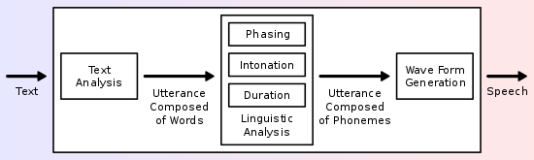

Fig 1.2: Text to Speech Conversion Process.

**pyttsx3** is a text-to-speech conversion library in Python. Unlike alternative libraries, it works offline and is compatible with both Python 2 and 3. An application invokes the pyttsx3.init() factory function to get a reference to a pyttsx3. Engine instance. it is a very easy to use tool which converts the entered text into speech.

**SMTP:**

SMTP stands for Simple Mail Transfer Protocol.

SMTP is a set of communication guidelines that allow software to transmit an electronic mail over the internet is called Simple Mail Transfer Protocol. It is a program used for sending messages to other computer users based on e-mail addresses. It provides a mail exchange between users on the same or different computers, and it also supports: It can send a single message to one or more recipients. Sending message can include text, voice, video or graphics. It can also send the messages on networks outside the internet.

The main purpose of SMTP is used to set up communication rules between servers. The servers have a way of identifying themselves and announcing what kind of communication they are trying to perform. They also have a way of handling the errors such as incorrect email address. For example, if the recipient address is wrong, then receiving server reply with an error message of some kind.

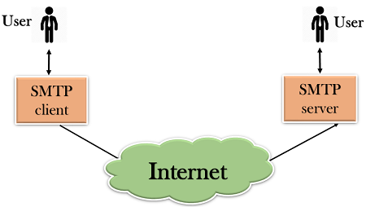

Fig. 1.3: SMTP

Python provides **smtplib** module, which defines an SMTP client session object that can be used to send mail to any Internet machine with an SMTP or ESMTP listener daemon. Here is the detail of the parameters −

--host − This is the host running your SMTP server. You can specify IP address of the host or a domain name like gmail.com. This is optional argument.

--port − If you are providing host argument, then you need to specify a port, where SMTP server is listening. Usually, this port would be 25.

--local_hostname − If your SMTP server is running on your local machine, then you can specify just localhost as of this option.

An SMTP object has an instance method called sendmail, which is typically used to do the work of mailing a message. It takes three parameters −

The sender − A string with the address of the sender.

The receivers − A list of strings, one for each recipient.

**IMAP:**

IMAP stands for **Internet Message Access Protocol**. It is an application layer protocol which is used to receive the emails from the mail server. It is the most commonly used protocols like POP3 for retrieving the emails.

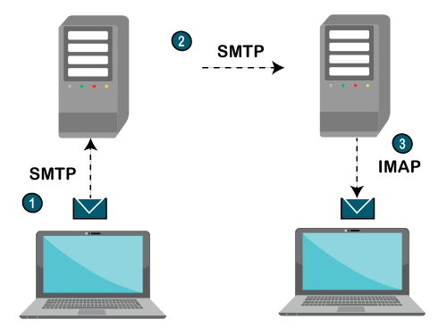

Fig. 1.4: IMAP

IMAP is a client-server protocol like POP3 and most other TCP/IP application protocols. The IMAP4 protocol functions only when the IMAP4 must reside on the server where the user mailboxes are located. In c the POP3 does not necessarily require the same physical server that provides the SMTP services. Therefore, in the case of the IMAP protocol, the mailbox must be accessible to both SMTP for incoming mails and IMAP for retrieval and modifications. The IMAP uses the Transmission Control Protocol (TCP) for communication to ensure the delivery of data and also received in the order. The IMAP4 listens on a well-known port, i.e., port number 143, for an incoming connection request from the IMAP4 client. Python's client-side library called **imaplib** is used for accessing emails over IMAP protocol. IMAP stands for Internet Mail Access Protocol.

**FLASK:**

In order to register new users, and validate existing users during the login process, a database to store user details is required. This is created using Flask, SQLAlchemy. Flask-SQLAlchemy is a Flask extension that adds support for SQLAlchemy to the Flask application. SQLAlchemy, the Python Toolkit is a powerful OR Mapper, which provides application developers with the full functionality and flexibility of SQL. Object-relational mapping is a technique through which we can perform certain operation on RDBMS table. The ORM API provides a way to perform CRUD operations without writing raw SQL statements.

**OS module:**

The OS module in Python provides functions for interacting with the operating system. OS comes under Python’s standard utility modules. This module provides a portable way of using operating system dependent functionality. The **os** and **os.path** modules include many functions to interact with the file system.

1. **OBJECTIVES**

• To provide the visually impaired people, a Voice Based Mailing application, a platform using which they can easily receive or send emails without any third person’s help or interference.

• Using Interactive Voice Response, people will control their mail accounts using their voice only and would be able to read, send, and perform all the other useful tasks.

• Use of keyboard is completely eradicated, the user will have to respond in the form of speech itself.

1. **LITERATURE SURVEY**

|  |  |  |
| --- | --- | --- |
| Name of Paper | Author | Findings |
| Voice based Email system using AI | Rijwan Khan, Pawan Kumar Sharma | Basic understanding of how the existing email system work and how we can resolve drawback of existing e-mail system using Artificial Intelligence |
| Voice based Email system | Prof. Manasi Choche | huge number of people who cannot avail services of various other applications as well as email services due to they being visually impaired, so this project is being developed keeping in mind the hurdles faced by these people |

1. **EXISTING SYSTEM**

The Existing system does not support any voice commands or audio facilities and therefore it is not suitable for visually challenged people. Also, various existing search engine which take request in form of text from user and retrieve the relevant documents from the server and respond by displaying it in the form of text which is not accessible by the visually challenged people. All operations in existing E-mail systems are dependent on mouse click events.

1. **PROPOSED SYSTEM**

The Proposed system will make the Traditional E-mail systems easily accessible to visually challenged people and also be of great help to the society. The Proposed system is being implemented, while keeping one idea in mind that it should be easily accessible for all kind of individuals. This system is accessible by any individual, whether they be visually challenged or not in an efficient manner. The Proposed System will take care of user-friendliness of traditional users, and will also focus on user-friendliness of all kinds of individuals. In this system, the system is going to be prompting the user to perform specific operations to avail various services and if the user wishes to access various services then he/she has to perform that operation. Firstly, the user will have to register in the system through the registration form. The user goes to be assisted through voice commands, whereas while registering, all the mandatory fields to be filled are going to be scanned by the website; once the user would speak, it would get written automatically. After successfully registering, the user can log in by speaking the Username and Password when prompted by the system, this username and password will then be converted from speech to text and then the user will be authenticated by verifying the credentials with the database. Users can access various sections like Compose, Inbox, and Sent Mail after successful login.

1. **SCOPE OF THE PROJECT**

• This type of system has great scope in the domain of HCI (Human Computer Interaction).

• The system would be beneficial to visually impaired people and it will help them to use modern day applications with ease.

• The Voice based technologies and NLP could be used in different applications as well such as gaming, robotics etc.

1. **ARCHITETURE DIAGRAM**

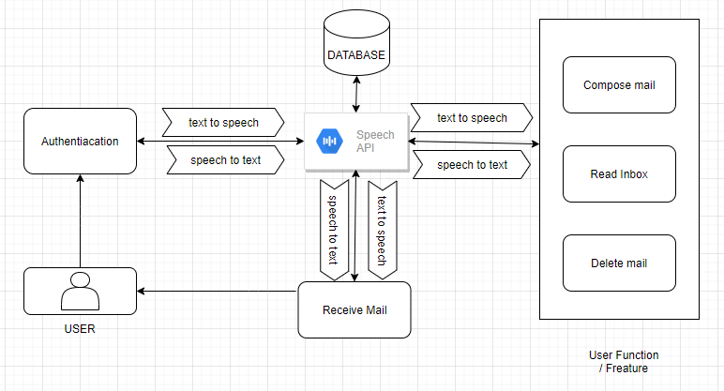

Fig 1.5: System Architecture

**IX. PROJECT IMPLEMENTATION**

**MODEL 1**

**REGISTRATION:**

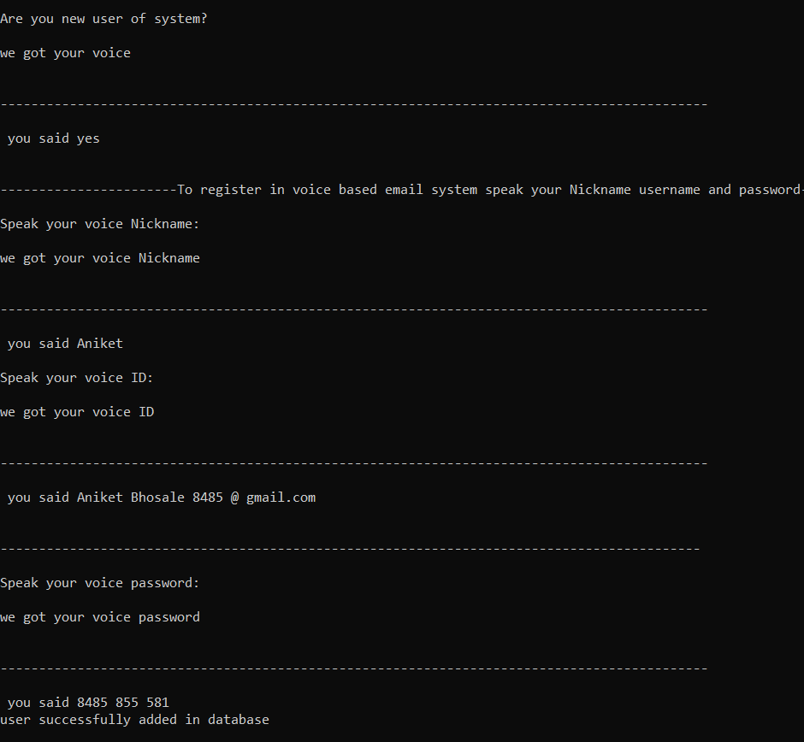

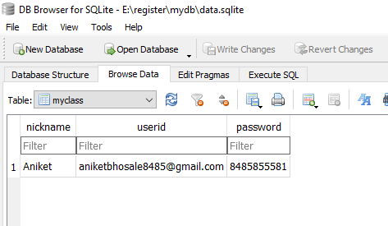

**MODEL 2**

**LOGIN:**

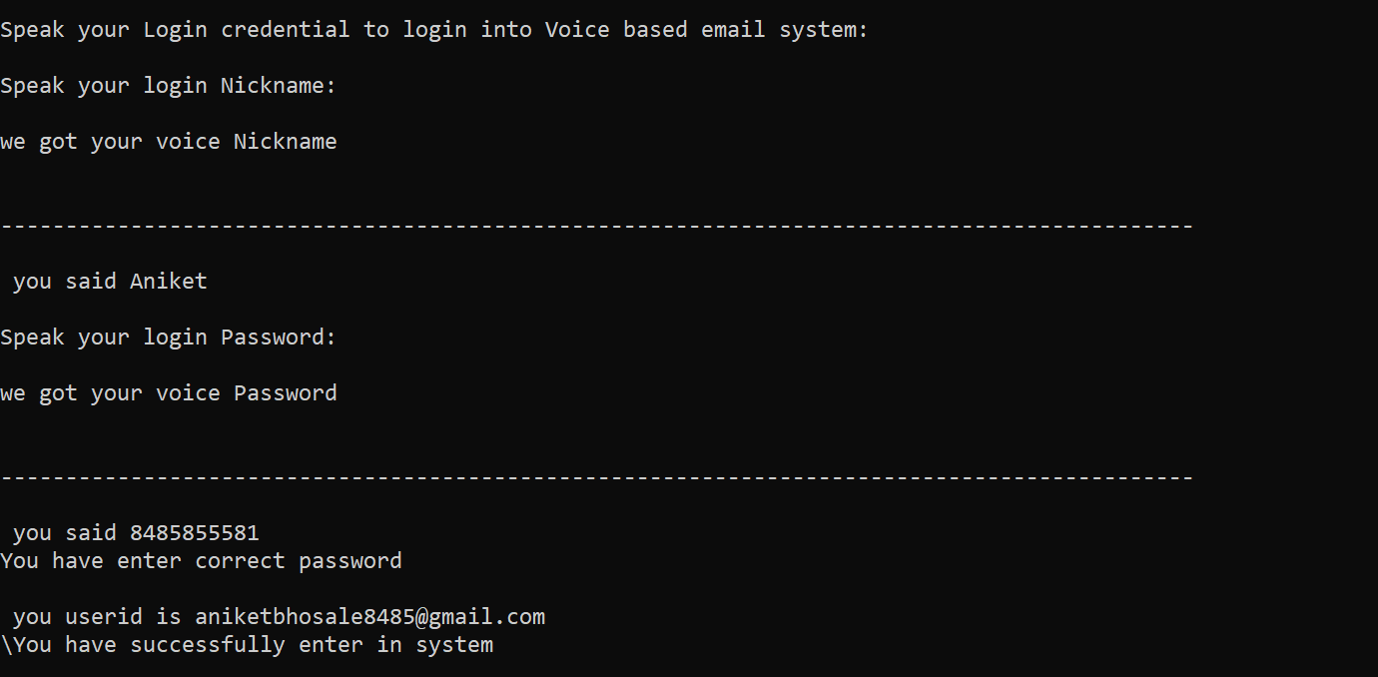

**MODEL 3**

**COMPOSE MAIL:**

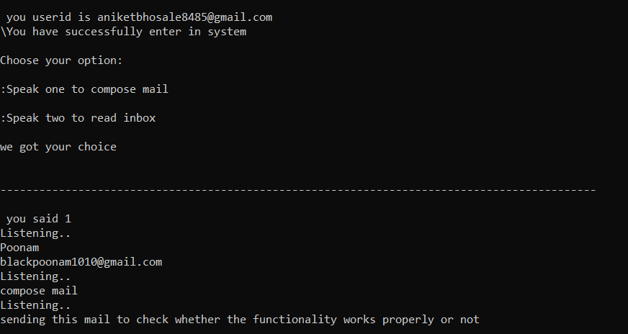

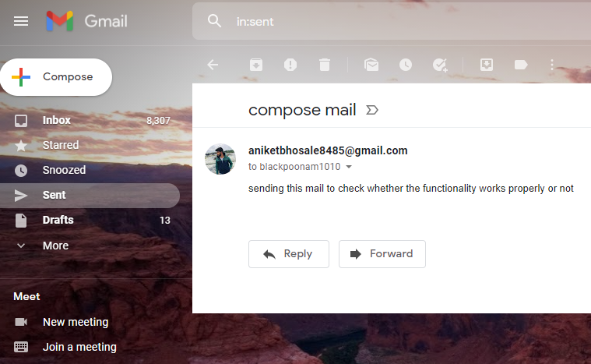

**MODEL 4**

**READ MAIL:**

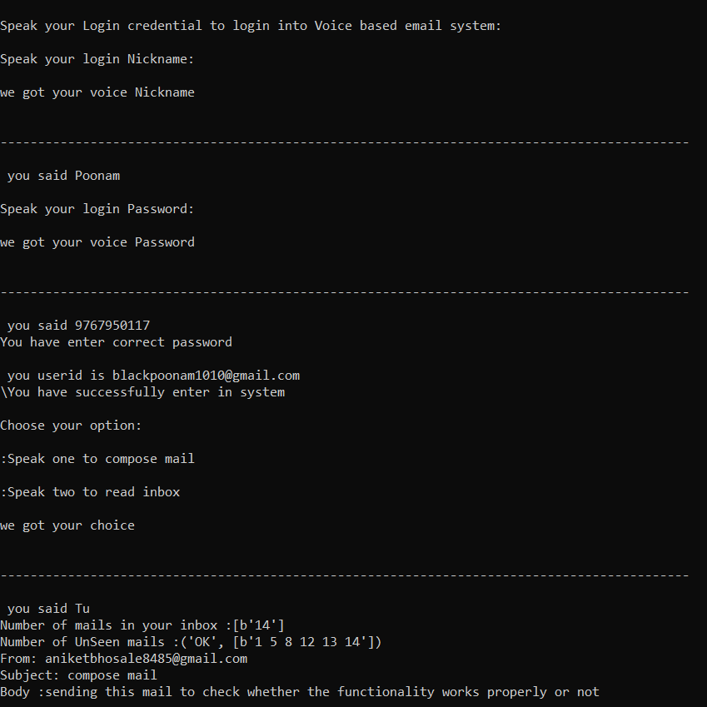

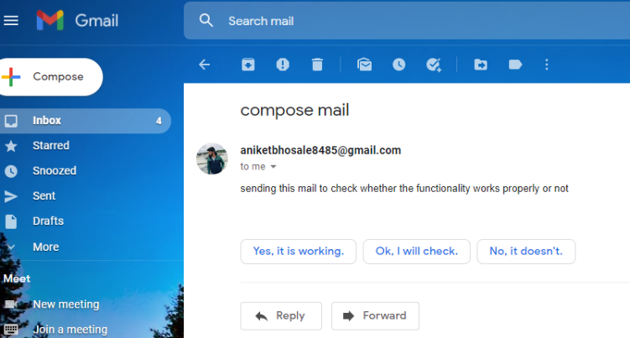

**X**. **CONCLUSION**

This E-mail system can be used by any user of any age group having any physical inabilities with ease access. It has the features of speech to text as well as text to speech conversions with speech reader which makes designed system to be handled by visually impaired people considerably easy and efficient.

**XI. REFERENCES**

[1]. Voice based Email system using AI Rijwan Khan, Pawan Kumar Sharma

[2] VOICE BASED EMAIL SYSTEM Prajakta Chavan, Devesh Jain, Pradnya Savant, Zeba Shaikh, Xavier Institute of Engineering, Mahim Jagtap Nilesh, Pawan Alai, Chavhan Swapnil and Bendre M.R.

[3] “Voice Based System in Desktop and Mobile Devices for Blind People”. In International Journal of Emerging Technology and Advanced Engineering (IJETAE), 2014 on Pages 404-407 (Volume 4, issue 2).

[4] [www.geeks.com](http://www.geeks.com)

[5] [www.tutorialspoint.com](http://www.tutorialspoint.com)

[6] [www.google.com](http://www.google.com)